Project Title: "Eco-Friendly Modular Furniture Solutions"

Name: Siva Rama Krishna Reddy Bhumireddy

GitHub URL: <https://github.com/bhumireddysivaramakrishnareddy/Database-Week-03.git>

SQL Environment: Windows

**ERD (Physical Model):**

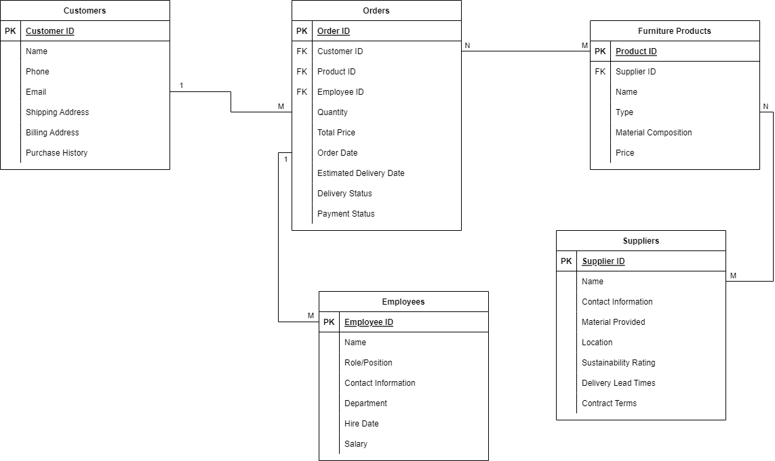

**ERD (Logical Model):**

**Relationship Description:**

1. **Customers to Orders Relationship**:

* Each Order is associated with exactly one Customer. This is a mandatory relationship since every order must have a customer associated with it.
* A Customer can have zero or more Orders. This is an optional relationship from the customer's perspective, as not every customer needs to have an order.

1. **Orders to Furniture Products Relationship**:

* An Order can include one or more Furniture Products. This is mandatory, as an order must contain at least one product.
* A Furniture Product can be part of zero or more Orders. This is optional for the Furniture Products, as there might be products that have never been ordered.

1. **Suppliers to Furniture Products Relationship**:

* A Furniture Product can be made from materials provided by one or more Suppliers. This is mandatory, as every furniture product must have at least one supplier for its materials.
* A Supplier can supply materials for zero or more Furniture Products. This is optional for the Suppliers, as not every supplier's materials are used in every furniture product.

1. **Employees to Orders Relationship** (Employee manages Orders):

* An Employee can manage zero or more Orders. This is optional, as not all employees will be involved in managing orders.
* Each Order is managed by exactly one Employee. This is mandatory, as the company policy dictates that every order must be overseen by an employee for quality control and customer service purposes.